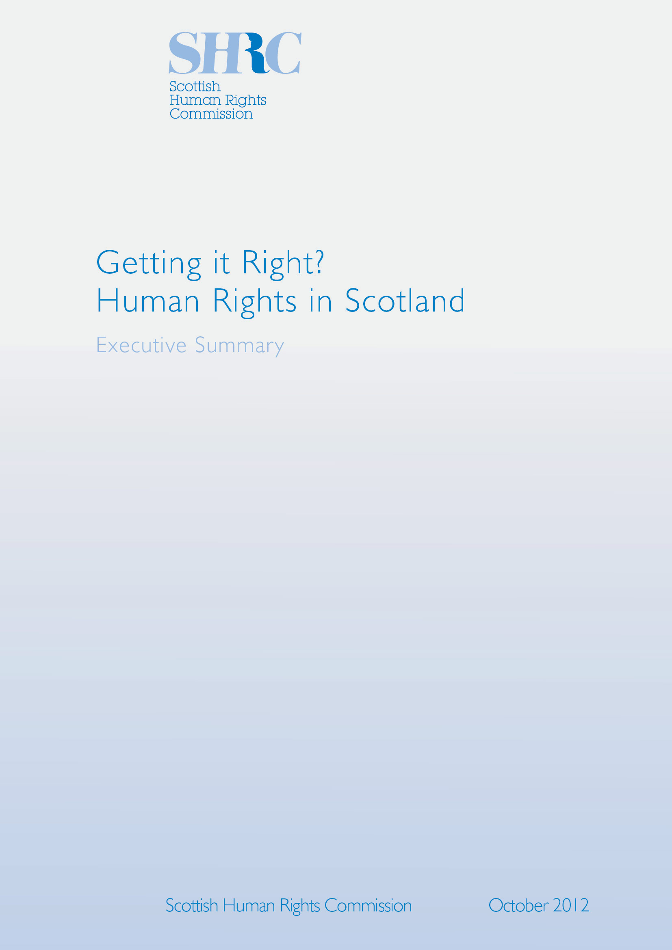
Contents

Foreword 3

Introduction 4

Key Messages 5

Table 1: Overview of findings on human rights structures,
processes and outcomes 5

Contexts 7
Legal Context 7
Political Context 8
Economic Context 9
Social Context 10
Environmental Context 11
Technological Context 11

Themes In Focus 12
1. Dignity and care 12
2. Health 13
3. Where we live 14
4. Education and work 15
5. Private and family life 17
6. Safety and security 18
7. Living in detention 20
8. Access to justice and the right to an effective remedy 21

Moving Forward 24

Table 2: Key Dates 25

National Action Plans in other countries 26

Foreword

This publication presents the findings of a three year project in which the Scottish Human Rights Commission (SHRC) has reviewed research on the realisation of internationally recognised human rights in Scotland. This is not intended to be a comprehensive ‘state of human rights in Scotland’ report, but a prompt for discussion in the development of Scotland’s National Action Plan for Human Rights.

The report suggests that while Scotland has made notable progress, it can do better.
It has a relatively strong legal and institutional framework for human rights, some examples of positive strategy and policy direction, but the actual outcomes for people often remain inconsistent.

Scotland therefore needs a more systematic approach to assure and not assume the realisation of human rights in practice. Strong human rights based legal and policy frameworks must be translated into more consistent, positive outcomes to which individuals are entitled.

The United Nations recommends the adoption of a National Action Plan for
Human Rights. National Action Plans are evidence based, developed in an inclusive way and independently monitored. They are concrete plans to fill ‘gaps’, build on good practice and help countries look outwards and move forward. Experience from Nordic and Commonwealth countries, amongst others, shows the potential of this approach to deliver real and sustainable improvements in the realisation of rights for all, particularly
the most marginalised.

SHRC is facilitating an open and inclusive process of development and monitoring of Scotland’s National Action Plan for Human Rights. This will include a National InterAction (a facilitated negotiation of commitments) on International Human Rights Day, 10 December 2012, and various other opportunities for involvement until March 2013. Preliminary engagement by SHRC with civic society, central and local government and political parties has found support in principle and gives us confidence that agreement on the National Action Plan can be reached in 2013.

We invite you to join SHRC in ensuring that Scotland’s National Action Plan for Human Rights leads to significant and sustainable improvements in the way that Scotland assures the realisation of all human rights by everyone.

Professor Alan Miller, Chair
Professor Kay Hampton, Commissioner
Shelagh McCall, Commissioner
Matt Smith OBE, Commissioner
October 2012

Introduction

The Scottish Human Rights Commission (SHRC) seeks to empower people to know and claim their rights, and to increase the ability and accountability of public and private bodies to deliver on human rights in Scotland. In support of these goals SHRC promotes the evidence based and inclusive development of Scotland’s National Action Plan for Human Rights - a road map to the further realisation of all human rights in practice in Scotland. This paper presents a summary of some of the key gaps and good practices which have emerged from a scoping project undertaken by SHRC. This is not intended to be a comprehensive ‘state of human rights in Scotland’ report, but a prompt for discussion in the development of Scotland’s National Action Plan for Human Rights. With this in mind, individuals and organisations are encouraged to consider their views in response to two key questions:

1. Based on the evidence presented in the report Getting it right? Human rights in Scotland, or your own experience, what do you consider to be the most urgent human rights issues which should be addressed in Scotland’s National Action Plan for Human Rights?

2. What specific and achievable actions do you consider would best address the concerns you identify in your response to question 1?

This report summarises the findings of a scoping project based on a literature review of social research, three legal literature reviews on references to specifi c international human rights treaties in relation to Scots law, as well as SHRC’s own experience since 2008. SHRC also convened a series of small focus groups and in-depth interviews with a range of communities, groups and individuals in Scottish society. In line with the SHRC’s statutory mandate, particular attention was given to hearing from those who tend to be marginalised and whose voices are less often heard in mainstream debates surrounding human rights. In taking this approach SHRC sought to put a ‘human face’ on the issues uncovered in the scoping.

This report does not comprehensively cover every human rights issue in Scotland. Rather, the Commission has chosen to present some of what appears to be the key human rights gaps and good practices that emerged from the scoping project.

Key Messages

There is some cause for optimism but certainly not for complacency as inconsistencies were noted in several areas, as is exemplified in Table 1 (below). It was found that in terms of structural steps, that is the operation of law and institutions, references to human rights were frequent and explicit in the Scottish context. However, regarding process steps, that is the enactment of policies and strategies, very few are currently rights based in nature although there was some potential identified. Outcomes, it was found, contained the greatest risk to the realisation of human rights in Scotland - that is where human rights can actually make a difference to the day to day lives of people in the country. SHRC argues that it is this last area that requires urgent attention, especially when viewed through the lens of the eight thematic areas identified later in this Executive Summary.

Table 1: Overview of findings on human rights structures, processes and outcomes

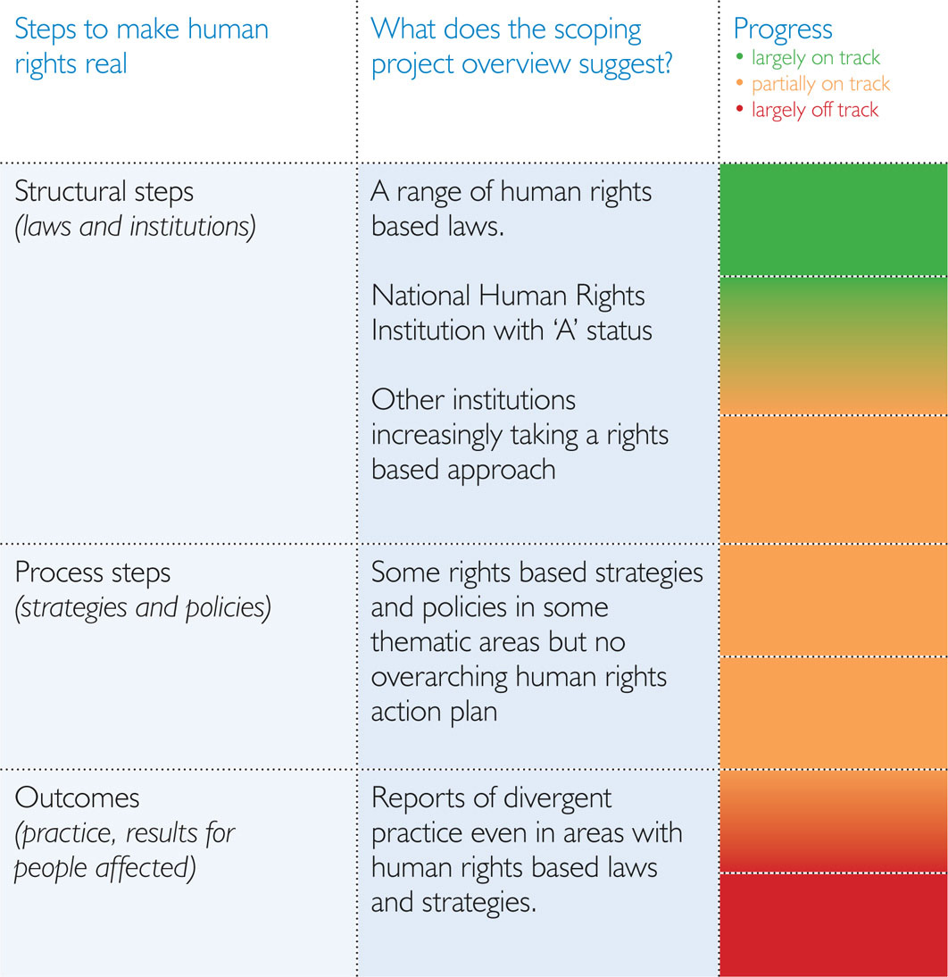

Structural steps:
Structural steps are the legal and institutional measures to protect human rights. They include the ratification of human rights treaties, domestic laws to incorporate those international obligations and establishing institutions to ensure accountability for putting human rights into practice. The Human Rights Act 1998 (HRA) incorporated the European Convention on Human Rights (ECHR) and together with the Scotland Act 1998 it forms a foundation for the legal protection of civil and political rights in Scotland.

Process steps:
The full realisation of human rights requires the adoption of effective measures or processes such as the development of appropriate strategies and policies, and the allocation of adequate resources. Awareness and capacity building can also be an important vehicle to put human rights into practice, as can practical approaches such as impact assessment. A human rights based approach has been explicitly integrated in some strategies and policies in particular areas in Scotland, the National Dementia Strategy is a clear example.

Outcomes:
Assessing human rights outcomes requires evaluating the extent to which the lived experience of the population matches up to the requirements of international human rights law. A key tool to do this is human rights indicators. Under a joint project of SHRC with the Equality and Human Rights Commission (EHRC), the London School of Economics and the British Institute for Human Rights produced an initial Human Rights Measurement Framework for England, Scotland and Wales. The scoping indicates that human rights outcomes appear to vary greatly, even in areas where laws and policies explicitly suggests that practice should be rights based. There are also however an increasing number of good practice examples in Scotland of organisations seeking to introduce a human rights based approach to their work.

Although the scoping project notes a few examples of putting rights into practice, it suggests inconsistency in a number of areas, even where laws and policies are largely rights based. Indeed, in general terms, it is noted that the influence of human rights is felt most strongly on our laws and institutions and its influence decreases the closer to real life we look. The result is unacceptable outcomes for some individuals, particularly the
most marginalised.

Based on these findings, SHRC considers that Scotland needs to better promote the influence of human rights laws in areas that matter most to people e.g. where we actually lead our lives - in our homes, neighbourhoods, workplaces, schools and other areas of day to day life. Scotland’s National Action Plan for Human Rights will provide a practical roadmap to move from assumption to assurance that human rights laws and institutions, strategies and policies are informed by and consistently influence practice. Adopting such a systematic approach will demonstrate a clear commitment to making human rights real for everyone in Scotland.

In publishing this report SHRC is also launching a process to develop Scotland’s
National Action Plan for Human Rights. To find out more, visit
www.scottishhumanrights.com/actionplan

Contexts

Human rights do not exist or operate within a vacuum. To appreciate the current status of human rights in Scotland it is important to examine and appreciate the broader political, economic, social, technological, legal and environmental contexts. Although there is a robust legal framework in place, Scotland’s political debate on human rights has too often been slowly reactive in design.

Political decisions in response to the current economic crisis are threatening the realisation of human rights. However public service reform presents clear synergies and opportunities for the integration of a human rights based approach. Socially, Scotland’s ageing population presents challenges that social policy is seeking to address while significant disparities in poverty levels remain and our social attitudes do not always match our self-perception as being inherently ‘fair’. Environmentally, Scotland has politically committed to a human rights based approach that it must now translate into reality. Technology is double sided, offering opportunities where internet connectivity can be advanced, but the proportionality of interference with the right to private life through intrusive use of technology has to be more systematically ensured.

Legal Context

The UK has made a range of international legal commitments to respect, protect
and fulfil human rights. However, it has been slow to grant the population the right to petition international human rights bodies where they believe their rights have been violated and they have not received a domestic remedy. Similarly, the UK has only incorporated one international human rights treaty, the ECHR, which mainly protects civil and political rights. The majority of the ECHR is incorporated via the HRA, which also includes a series of mechanisms to pursue the realisation of those rights in practice:

• Domestic courts are required to take account of the case law of the European Court of Human Rights (ECtHR).
• All laws must also be understood so far as possible in a manner compatible with the rights contained in the HRA.
• Public authorities and others who undertake a public function must refrain from acting incompatibly with the rights in the HRA.

Additional measures may be required to clarify duties under the HRA, and to maximise its contribution to a human rights culture.

The HRA is also referenced in the Scotland Act 1998 and hence is embedded in the devolution settlement. The Scottish Parliament may not pass laws which are incompatible with the rights in the HRA. The Scotland Act also prevents the Scottish Government from making law or doing anything else which is incompatible with the HRA. The constitutional consequence is that any act of the Scottish Government which is incompatible with the ECHR would have no legal effect, and any legislation passed which was outside legislative competence is not law. While Scottish courts can only make “declarations of incompatibility” in respect of Acts of the UK Parliament, they can invalidate Acts of the Scottish Parliament if they are judged not to be compatible with the ECHR. In addition, both the Scottish Government and Parliament are required to take into account the whole range of international human rights obligations by observing and implementing them. The UK Government can also act to implement international obligations in Scotland, even in areas within the competence of the Scottish Parliament. In practice the Scottish Parliament has at times enacted laws which consciously adopt a human rights based approach. This has led to a number of laws of the Scottish Parliament being cited as good practice in human rights and in their subject field. In other cases, however, successive Scottish Governments and the Scottish Parliament have taken a more reactive approach, reluctantly engaging with some human rights issues.

Political Context

In Scotland, human rights are embedded in the present constitutional settlement and as such the balance of powers between legislative, executive and judiciary in Scotland is closer to increasing international experience where Parliaments are constrained to act in ways which are compatible with human rights rather than the British doctrine of Parliamentary sovereignty. This provides a formal basis from which to develop a more positive and proactive political engagement on human rights.

The current mechanisms to consider human rights in the work of the Scottish Parliament include statements of compatibility and a mainstreaming approach to human rights across its committees. The former may be contested as lacking transparency and public scrutiny, the latter as missing the potential for the Parliament to develop a specialist committee and clear space to discuss human rights issues.

In the case of Government Bills a member of the Scottish Government and the
Presiding Officer must both issue statements to the effect that the Bill is considered compatible with the Scotland Act (including that it is compatible with the ECHR). Scotland’s current political parties all express enthusiasm for human rights and a range
of rights based legal and policy measures have been adopted since the Scottish Parliament was established. Nevertheless, political action to respect, protect and fulfil human rights remains at times reactive rather than proactive as demonstrated by successive Scottish Governments’ responses to a series of cases. The place of human rights in Scotland’s constitutional settlement was an element in discussions surrounding the passage of the Scotland Act 2012, which seeks to implement recommendations of the Commission on Scottish Devolution (the Calman Commission).

At local government level Scotland has 32 elected local authorities which each has a Single Outcome Agreement with the Scottish Government. Such agreements have been politically contested. On the one hand they offer the potential for greater participation in decision making at the local level. On the other it has been argued that they create a challenge for national accountability and ensuring delivery of better outcomes across the country. Given that they currently represent a significant devolution of decision making over local services in areas such as education and housing, Single Outcome Agreements should be clearly linked to human rights realisation.

Economic Context

The global economic crisis has presented a significant challenge to human rights protection in the UK. Human rights can assist in responses to the crisis, offering an objective framework for fair decision making on the prioritisation of resources. Since the 2010 General Election the UK Government has prioritised the reduction of the public debt, pursuing a programme of austerity and cuts in public spending. This has had consequential impacts on the availability of resources for the realisation of human rights in Scotland.

In recognition of the need to adjust the delivery of public services to the new economic environment, the Scottish Government established an independent Commission to Consider the Future of Public Services (the Christie Commission). The Christie Commission concluded that there was a need for urgent and sustained reform to public services based on a series of principles and these findings have been endorsed by the Scottish Government. SHRC identifies significant opportunities for synergy between the principles of public reform recommend by the Christie Commission and a human rights based approach.

Domestic and international human rights bodies have called on UK and devolved administrations to consider more effective processes for assessing the impact of
legal, policy and practice steps on equality and human rights. A good practice model
for undertaking such impact assessments is currently being developed by SHRC with
the EHRC and in collaboration with many other public bodies. Some international
human rights bodies have also called for the development and use of human rights
budget analysis.

Social Context

Scotland’s population is changing and this has notable implications for the promotion and protection of everyone’s human rights. At just over 5.2 million, the population is now at its highest since 1977. Within this overall rise, the demographic structure variance between urban and rural authorities is marked, and the overall population is ageing. This rise in population (particularly linked to a projected rise in the number of ‘very old’ people) is predicted to reach 5.54 million by 2033. This also includes a projected rise of almost 75 per cent of people living with dementia by 2031 from current figures. These changes will have a marked impact on access to public services, with particular requirements to increase the availability and accessibility of services for older people. Scotland is developing significant policy responses such as the integration of health and social care and there are clear opportunities and benefits to be drawn from including a human rights based approach in major policy responses to demographic change.

Barriers to realising human rights drive and deepen experiences of poverty and in
turn social exclusion. Some anti-poverty initiatives in Scotland have adopted elements of
a human rights based approach. The Poverty Truth Commission, for example, highlighted key human rights messages such as the importance of ensuring people living in poverty are provided the opportunities and supported to participate in shaping responses. In practice, action to address poverty has made progress in respect of certain population groups such as adults of pensionable age and children, but not for others such as
workless households.

Since devolution, considerable progress has been made in addressing many
inequalities in Scottish society, for example, in relation to the proportion of people living in poverty, rates of those out of work and improved education outcomes. Yet significant problems remain and these inequalities act as barriers to the full realisation of human rights and some of the most widely reported inequalities challenging Scotland are in respect of health.

Scotland is often portrayed as a nation of people who value the concept of ‘fairness’. This has strongly informed its self perception. While there is some evidence that Scotland has become more open and accepting there remains a distinct gap between perception and reality. Although some progress has been made in recent years in relation to the promotion of equality across a wide range of sectors of Scottish society, discriminatory attitudes have not reduced consistently. Attitudes towards gay and lesbian people have improved, but there remain high levels of discriminatory attitudes towards, among others, transgender people and Gypsy/Travellers. Likewise, disabled people appear to face a disproportionately high level of prejudice.

Environmental Context

Scotland has world leading legislation on climate change mitigation targets and an adaptation strategy, both welcomed internationally. Recently the Scottish Government committed to promote climate justice and a human rights based approach to climate change, including through the launch of a Climate Justice Fund based on recognition of the unfairness that those who had contributed least to the causes of climate change are suffering its most extreme consequences.

Despite these positive steps concerns related to human rights and the environment persist. In 2010 the UK was criticised for failing to ensure access to justice in environmental matters due to the prohibitive costs associated with challenging environmental planning decisions. This is an issue on which the European Commission is pursuing the UK before the European Court of Justice, and which has been the subject of a public petition to the Scottish Parliament.

Technological Context

Human rights defenders around the world have enthusiastically embraced technological advances to enhance their research, advocacy and campaigning goals. Access to the internet is increasingly required to fully exercise the right to access information, and consequently the right to participate in decisions. While access to the internet does not vary significantly between rural and urban areas in Scotland, differential rates do exist for older people, those on lower incomes, those with fewer educational qualifications, the unemployed, disabled people and those with long term illnesses.

Technological progress also offers significant challenges to human rights. In Scotland these have often related to the right to respect for private life and how that is protected in public and private space, as well as security of information. Concerns related to the proportionality of interference with private life also arise in relation to the use of Closed Circuit Television (CCTV), monitoring of email, telephone and other communications. Similarly the use of new technologies in combating crime has to be considered through the lens of human rights. Recent controversies relate to the retention of DNA and other forensic data, and the use of electro-shock weapons.

Themes in Focus

The report presents issues under eight broad thematic areas:
1. Dignity and care
2. Health
3. Where we live
4. Education and work
5. Private and family life
6. Safety and security
7. Living in detention
8. Access to justice and the right to an effective remedy

Theme 1: Dignity and care

While human dignity is an underlying principle relevant across all rights and all spheres of life, the theme of Dignity and care is used here to refer to a range of issues and the report provides an overview of what appear to be some key human rights gaps and good practices under the headings of:

Quality of care:
A great deal of attention was paid in the research reviewed to the quality of care services in Scotland, especially those aimed at children and young people, older people, and people with disabilities. There are a wide range of human rights that are potentially affected by the delivery of care services, such as the right to life and the right to freedom from torture, inhuman or degrading treatment or punishment and the right to respect for private and family life. Article 8 of the ECHR is most relevant here. Other issues identified include: funding and the extent of “free” personal care; the integration of a human rights based approach into the procurement of care services. The benefits of a human rights based approach identified from the Care about Rights project developed by SHRC in partnership with a range of other organisations are also presented.

Independent living:
The right to live independently as part of a community is guaranteed in Article 19 of the UN Disability Convention. It focuses on the choice of a disabled person of where and with whom to live, and being able to live in a community in a manner that supports and fosters inclusion and participation. The “co-production” approach to independent living and de-institutionalisation were identified as positive steps. However there were concerns regarding portability of care. The moves towards Self-Directed Support and personalisation were highlighted as opportunities for further integration of a human rights based approach. Access to services by disabled people is also considered.

Self-determination:
Self-determination, autonomy and participation are central principles in human rights law. Issues which arose from the scoping project included legal capacity, the use of guardianships and end of life decisions.

Carers’ rights:
The report highlights increasing recognition of the connection between the impact of unpaid caring responsibilities and human rights, including the right to an adequate standard of living, the right to work and the right to respect for private and family life.

Theme 2: Health

Under the theme of Health the report provides an overview of what appear to be some human rights gaps and good practices in the following areas:

Integrating a human rights based approach in health, law and policy making:
The opportunities to advance human rights in health care through the Patients’ Rights Act and Charter as well as the development of Health Inequalities Impact Assessment processes are identified in the report, as are steps to increase participation in decision making in health contexts. The report also considers the extent to which accountability mechanisms fulfil the requirements of a human rights based approach and opportunities arising from the pursuit of No Fault Compensation.

Healthcare quality:
The report considers opportunities for the further integration of human rights in healthcare delivery connected with the Healthcare Quality Strategy. Despite a general satisfaction with the quality of care received some research suggests concerns related to, amongst other things: unintentional harm; contracting infections such as MRSA; and concerns related to delayed discharge.

Health promotion:
Addressing underlying determinants of health is a core component of the right to the highest attainable standard of health. The report cites research demonstrating that lifestyle choices remain a significant health challenge in Scotland including in relation to smoking, diet and alcohol consumption. Research also indicates that health outcomes are also related more “fundamental” factors such as deprivation and poverty, an ageing population and a complex geography with large and sometimes sparsely populated rural areas. The impact of increased pressure on public funds in a time of recession was also identified in some sources.

Non-discrimination within health care:
The right to health includes an obligation to ensure that health facilities, goods and services are accessible to all without discrimination. In this context there are four dimensions to consider: non-discrimination (in law and fact), physical accessibility (including in rural areas and for disabled people), economic accessibility and information accessibility. The research identifies issues faced by groups such as minority ethnic and religious communities, as well as people with disabilities and LGBT people, and the research also indicates particular challenges in accessing health services faced by those living in rural areas.

“Health care services need to be both well resourced and competent, we often struggle to attract staff to the islands … it’s not uncommon to have clients kept in hospital or respite because of the lack of resources in the community.”

Karen, 3rd sector advocacy worker

Mental health care and treatment:
The care and treatment of patients in and outside of mental health institutions engages a range of human rights including the right to life, the right to liberty, the right to freedom from torture, inhuman or degrading treatment or punishment, and the right to respect for private and family life. The report considers responses to mental health stigma, access to mental health care, quality of mental health care of treatment (including restraint, seclusion and reports of individuals being forced to take certain medications) and specific concerns for those patients receiving dementia care.

Theme 3: Where we live

The theme of Where we live is used here to refer to a range of issues and the report provides an overview of what appear to be some key human rights gaps and good practices under the headings of:

The right to adequate housing:
The right to adequate housing has various dimensions, including security of tenure; availability of services; affordability; accessibility; habitability and cultural appropriateness of housing. Some of the issues identified in the report include: the availability of housing and steps to address homelessness; access to adequate housing for all without discrimination; affordability and security of tenure; habitability including the appropriateness of the current standard of “tolerable housing” and fuel poverty. Discrimination in seeking housing is also an issue that emerged from the scoping project, especially for minority ethnic communities and groups such as ex-offenders.

The rights of those living in rural areas:
Disparities in access to services between those in rural and urban areas potentially raise human rights concerns. Issues identified in the report include: increased poverty; a lack of available and accessible services including housing, care and support, education, transport and healthcare; lower than average income levels, with employment concentrated in a small number of low productivity sectors.

Where Scottish Gypsy/Travellers live:
The rights of members of Gypsy/Traveller communities in Scotland have been the subject of review by a number of national and international human rights bodies which have made repeated recommendations. Concerns identified in the report centre on a persistent shortage of adequate permanent and transit sites throughout the country, resulting in frequent evictions and tensions with the majority settled population.

Theme 4: Education and work

Under the theme of Education and work the report provides an overview of some apparent human rights gaps and good practices under the headings of:

Access to education:
The right to education includes an obligation to ensure that education is available, accessible, acceptable and adaptable. The report highlights research raising concerns related to the equal realisation of the right to education of: disabled children; children of Gypsy/Travellers; children of asylum-seekers; children excluded from education; non-attendees (due to sickness, family obligations etc) - pregnant young women and young mothers of school age. In relation to disabled children, research also suggests barriers such as inaccessible educational institutions and policies that do not cater to disabled students as well as the continuation of prejudicial attitudes. Disparities in relation to social economic status and questions around access to higher education by UK residents from outside Scotland were also identified.

Inclusive education:
The right to education includes a duty to pursue an overall goal of full inclusion of children with disabilities. The report reveals competing views as to what inclusion means, in particular for children and young people with complex needs - for example, some commentators argue for adapted and supported provision within mainstreaming education whilst others argue for placing pupils in designated special needs institutions. Children considered particularly vulnerable include those with Autism Spectrum Disorders (ASD) or Attention Deficit Hyperactivity Disorder (ADHD).

Access to and fair treatment at work:
The right to work and fair treatment at work includes a duty to ensure non-discrimination in access to work, and a spectrum of rights at work. The report cites research which suggests that a range of groups in Scottish society experience discrimination and inequality in accessing work as well as a lack of support mechanisms to assist such groups to first gain employment and then be treated fairly whilst in work. Examples of such affected groups are: parents with children in working families, ethnic minorities, migrants and asylum seekers, disabled people and people who have mental health conditions.

“Are you going to be treated worse because you have said that you are a Gypsy/Traveller, are you going to be treated better or worse? You’ve got this attitude because you have been harassed all your life, ‘collar and ties’, ken? Services with authority, I have never trusted and I still don’t trust.”

Mary, Scottish Gypsy/Traveller

Fair pay:
The right to remuneration sufficient to secure an adequate standard of living is a core element of human rights at work, as is the right to equal pay for work of equal value. The report notes research indicating a significant gender pay gap in Scotland and that fair pay is a productive way to assist individuals and families to combat poverty. Research suggests that young people and those with dependent children are more vulnerable to poverty in unstable and low paid employment. Concerns have also been raised by international human rights bodies at the adequacy of the minimum wage, although the pursuit of a living wage was identified as positive by some. However, some continue to have concerns that groups such as migrant workers may not be receiving the wages they should.

“... the rent is extortionate and they can be in there for 6 months to a year, sometimes plus and it is financially impossible for them to work during that time... it becomes an absolute nightmare to manage because they are then having to pay towards their rent which can be about £200 plus a week. A lot of the young people I work with are in that situation - they are on job seekers allowance and they are getting a lot of pressure from the job centre to prove that they are seeking work, when in actual fact it’s just not within their interests financially to do that because they don’t gain anything from it and if anything they are out of pocket, so that is a barrier for them, but the odds really are stacked against them.”

Francis, Personal Development & Employability Worker

Theme 5: Private and family life

Under the theme of Private and family life the report provides an overview of what appear to be some human rights gaps and good practices under the headings of:

Domestic abuse:
States have human rights obligations of prevention, protection and remedy to address domestic abuse. The report notes that anti-domestic abuse initiatives have featured prominently in public policy in Scotland and have received attention and funding from Government. This focus reflects its prevalence in society as well as increased awareness. Some have, however, raised questions about the definition of domestic abuse in law, as well as the adequacy of policy attention to perpetrators and specific groups of victims/survivors including minority ethnic women, transgender people and men. The positive experience of a domestic abuse court is also highlighted in the report.

“I asked I don’t know how many times for social work to help and intervene with my son. You could see he was having problems dealing with the aftermath of what had happened, but no, the request had to come from the school or another agency, it couldn’t come from me. There I was saying, please help us, we need help now, but it had to come from someone else.”

Lisa, mother and victim of domestic abuse

Forced marriage:
Forced marriage is a human rights abuse. Though the scoping project found limited evidence of forced marriage in Scotland, in 2011 new legislation was adopted bringing Scotland into line with the approach in England, Wales and Northern Ireland. The report cites research suggesting that, as yet, little use has been made of its provisions.

Same-sex marriage:
States may extend the right to marry to same sex couples. The report considers debates surrounding Scottish Government plans to provide for same-sex marriage including the appropriate balance between the human rights to marry, to be free from discrimination and to freedom of religion.

The right to respect for family life for people with learning disabilities:
Research cited in the report indicates that people with learning disabilities continue to face particular barriers to realising their right to respect for private and family life, including establishing relationships. The report considers the appropriate balance between state duties of protection, and the freedom that individuals have to establish relationships, including sexual relationships. The application of domestic law related to legal capacity, adult support and protection and sexual offences is also considered. Despite measures to raise awareness of these issues and how to respond to them, focus group participants working in different settings with people with learning disabilities considered that more remained to be done.
The rights of parents and children:
Children and adults have a right to respect for private and family life . A range of other rights in the UN Convention on the Rights of the Child are also relevant. Some research cited in the report indicates a lack of recognition of the rights of the child in practice. The report also considers the implications of the differences in treatment of mothers, and married and unmarried fathers. For example the report notes concerns among some with regard to the rights of the child as well as the rights of fathers to see their children after the breakdown of relationships.

Parental imprisonment:
The UN Convention on the Rights of the Child upholds the child’s right to maintain personal relations and direct contact on a regular basis, except if it is contrary to the child’s best interests. An estimated 16,500 children in Scotland are reported to be affected every year by the imprisonment of parents and carers. The report cites research suggesting that, as a result and in addition to the emotional loss of contact with a parent, children may suffer from bullying, shame, stigma, stress, financial disadvantage, the loss of a carefree childhood and a need to move house.

Theme 6: Safety and security

Under the theme of Safety and security the report provides an overview of what appear to be some human rights gaps and good practices under the headings of:

Asylum:
Other than in narrow circumstances where rights are explicitly limited to citizens, human rights apply to everyone in the jurisdiction without discrimination on any ground. Asylum does not fall within the competence of the Scottish Parliament. However research cited in the report points to discrimination faced by refugees and the need for support in access to employment, welfare and healthcare.

Offences aggravated by prejudice:
States have human rights obligations to prevent and investigate crimes aggravated by prejudice including on grounds of ethnicity, disability, religion, sexual orientation and gender identity (or “hate crimes”). The report cites research which indicates that in the current economic climate hate crime appeared to be a growing concern in Scotland. Research appears to consistently note a link between discrimination and violence or other offensive behaviour. Questions raised by some regarding recent legislation on sectarianism in football are summarised. Some participants in focus groups also expressed concern that the authorities could at times do more to promote a climate where the reporting hate crimes is less intimidating. Emerging examples of good practice are also identified.

Abuse prevention, protection and remedy:
The prohibition of torture, inhuman or degrading treatment or punishment includes positive obligations of prevention, protection and response. The report highlights
that Scottish legislation on adult support and protection is founded on human rights principles. However concerns have been raised by some regarding the balance in the legislation between principles of autonomy and the State duty to protect people at risk
of ill-treatment.

Trafficking:
Effective measures of prevention, protection and investigation of trafficking in human beings are a human rights concern. Criminal offences in relation to human trafficking are included in a number of Acts in Scotland. However, the report cites research indicating that there has been a lack of prosecutions for trafficking offences in Scotland with the first convictions only secured in September 2011. Research suggests that victims of human trafficking may be missing out on support because authorities in Scotland have trouble identifying them as trafficking victims and this absence of recognition of their status means they are unable to access appropriate services or help police with their inquiries.

Policing:
The Human Rights Act 1998 requires all public authorities, including the police, to act in a way which is compatible with the individual rights and freedoms contained in the ECHR. Policing reform in Scotland is currently underway including the creation of a single police service for Scotland under the Police and Fire Reform (Scotland) Act 2012. Ways in which this structural change could afford the opportunity to strengthen the framework of police accountability in Scotland are discussed, as are debates surrounding the explicit referencing of human rights during the drafting of the Act. The report discusses the concerns raised by the proposal to transfer the functions of the Police Complaints Commissioner for Scotland (PCCS) to the Scottish Public Services Ombudsman (SPSO) and also welcomes the establishment of the Police Investigations and Review Commissioner as a new independent investigation mechanism. The report also discusses particular concerns in relation to policing and human rights identified in the scoping, which includes, the use of the stop and search powers as well as the Strathclyde Police pilot to roll out the use of electro-shock (TASER®) weapons beyond trained firearms officers.

“We teach our children this kind of hatred. Kids are colour blind and have no concept of religious difference … They are not biased, they learn their behaviours from others, they learn from their families and society. And it stays with them for a long time … you see how much hatred can come out of someone for someone else that they have never met before, it is incredible. Hopefully with the legislation, and given some time, people might start to think about the implications of their behaviour, start to think, I might have to pay for the implications of my act. In the past I did what my father did, but now I look at this and think, this is not something I am meant to do, it is not worth paying this price.”

Chiwetel, survivor of a racially motivated hate crime

Theme 7: Living in detention

Under the theme of Living in detention the report provides an overview of what appear to be some human rights gaps and good practices under the headings of:

Conditions of detention:
All detainees have a right to be treated with humanity and dignity. Research identified in the scoping project raised continuing concerns, to a greater or lesser extent, on issues such as overcrowding, ‘slopping out’, addiction (including a lack of needle exchange programmes), healthcare and mental health services (including mixed experiences of access to mental health care), and levels of suicides and deaths in custody. Access to productive activity, including education, work and exercise have also been reported as areas of concern.

Mental health detention:
Persons deprived of their liberty on mental health grounds must be detained in an appropriate therapeutic environment. The scoping indicates that the Mental Health (Care and Treatment) (Scotland) Act 2003 has been widely welcomed as having created a new framework for the use of compulsory measures, and placing emphasis on treatment and care in the community, on safeguarding patients’ rights and on enabling the participation of patients and carers in treatment and on-going care. Research cited suggests that since it came into effect there has been a decrease in use of compulsory powers, although this may vary across the country. Mental Welfare Commission reports identify a range of areas for improvement in mental health care and treatment in practice. Concern has also been raised regarding young people who are detained in adult wards as well as geographic variation in the standard and quality of provision of care and treatment. An independent evaluation of the human rights based approach at The State Hospital indicated significant benefits to staff, patients and carers.

Women in detention:
Significant concerns have been repeatedly raised regarding conditions of detention for women in Scotland, particularly in Cornton Vale. The report highlights that many consider there to be a need for further measures to increase and enhance educational, rehabilitative and resettlement programmes for women in prison and to ensure the provision of adequate health facilities and services, including mental health services, for women in prison. Multi-agency work is regarded as being important in the Scottish context. In 2012 the Commission on Women Offenders made 37 recommendations for change focusing on key areas including: alternatives to prosecution; alternatives to remand; sentencing; prisons; community reintegration; and leadership, structures and delivery.

Young people in detention/secure accommodation:
Under the UN Convention on the Rights of the Child children in detention should be separated from adults. In Scotland, most children who are accused of offences are dealt with under the Children’s Hearings System which the report notes has been widely praised nationally and internationally. The Children’s Hearing System takes a welfare approach which UK Children’s Commissioners consider has made it less likely that children in Scotland will be punished or locked in comparison to children in England. Nonetheless, the Scottish system has been criticised with regards to the level of deprivation of the liberty of children and young people over 16. Concerns have also been raised regarding the conditions of detention of children and young people in Scotland and with regard to the detention of asylum-seeking children.

Theme 8: Access to justice and the right to remedy

Under the theme of Access to justice and the right to remedy the report provides an overview of what appear to be some human rights gaps and good practices under the headings of:

Access to justice (including access to legal advice and legal aid):
Under the European Convention on Human Rights there is a general duty on states to ensure practical and effective access to justice. The report highlights concerns related to steps taken following the Cadder decision on access to a lawyer during questioning including: the provision of legal advice over the phone; periods of detention without charge; the option to waive the right to legal advice and inferences which can be drawn from a suspect’s silence. The report also notes that concerns have been raised regarding the availability and distribution of legal aid in times of recession and in steps to review financial contributions in criminal legal aid. A range of research has also identified ways in which certain groups and communities may be disadvantaged in the legal process, including: disabled people, victims/survivors of domestic abuse, asylum seekers and immigrants, and so-called “vulnerable” suspects and witnesses. Amongst specific issues identified in the research are: physical access; access to legal advice; information and communication barriers; and attitudinal issues. The potential implications of a more expansive approach taken by the UK Supreme Court to standing to raise public interest cases are noted as are the requirements of international agreements on access to justice in environmental matters, where UK practice has been found to be inadequate.

Juvenile justice:
The UN Convention on the Rights of the Child provides that children who have been charged with criminal offences must be dealt with in a manner which takes full account of their age, level of maturity and intellectual and emotional capacity. The report notes that the Children’s Hearings System is widely praised, but cites recommendations to increase its funding to reflect an increasing number of cases. The report also notes concerns at the low age of criminal responsibility in Scotland.

Criminal procedure:
The research notes concerns which some have been raised regarding the operation of the disclosure regime. These relate to the disclosure of previous convictions and disclosure of medical or mental health records. It also notes debates surrounding the operation of the rule requiring corroboration in criminal trials.

The duty of effective investigations:
Positive obligations under the right to life and the prohibition of torture, inhuman or degrading treatment or punishment include an obligation to hold an effective official investigation. In Scotland, Fatal Accident Inquiries (FAIs) are the means of investigation in cases of sudden, suspicious or unexplained death, or death in circumstances that give rise to serious public concern. Consideration has been given to the sufficiency of this mechanism to comply with investigation requirements until international human rights law.

Victims’ rights & the right to remedy:
The human rights of everyone involved in the criminal justice system, victims and witnesses as well as suspects, must be respected, protected and fulfilled. A common concern is with delays with legal proceedings and the impact of such delays on victims’ rights to effective remedies. The report highlights views that there remains a lack of recognition and that there are opportunities for further realisation of the human rights of victims of crime and human rights abuses. Further, opportunities to advance the right to an effective remedy are identified including facilitating effective apologies and revisiting the operation of the system of time limits for civil remedies. In addition, the report highlights recommendations made to address access to justice and remedies for survivors of historic child abuse.

“My expectations were that I would be treated fairly and that my rights as a human being would be respected. I would have access to information, the same range of resources and the same standards afforded to that of the man accused of stalking me … My experience of the criminal justice system was one of dismay and horror. If ever a system abused victims and denied vulnerable people of their very basic human rights, this was it. The focus of the criminal justice system is purely on the accused or offender and the system has been structured for this specific purpose. It had provided a pathway for these people and none for the victims … My stalker’s rights were catered for at all levels. His right to a fair trial, his treatment within the system, his access to services, his human rights being respected and fairness surrounding his sentencing … My experience highlighted that offenders have rights and victims have policies and guidelines.”

Emma, Victim of Crime

Moving Forward: A Scotland’s National Action Plan for Human Rights

This paper presents a summary of some of the apparent gaps and good practices which the SHRC scoping project has revealed. It is not intended to be a comprehensive “state of human rights in Scotland” report, but a prompt for discussion in the development of Scotland’s National Action Plan for Human Rights. Addressing the gaps and replicating good practice should be a concern of all bodies with responsibilities, including Government, local authorities, other public authorities and private providers of public services. Identifying the shared framework of responsibilities and agreeing steps to address gaps requires an inclusive process of engagement. It should result in clarity on what action such bodies will take and when concrete improvements can be expected - it should result in specific, measurable, achievable, relevant and time-bound objectives. An independent system for monitoring progress should also be agreed. In short, the report supports the conclusion that Scotland needs a National Action Plan for Human Rights. To develop this SHRC will host human rights InterActions involving a broad range of public and private bodies, civil society and individuals. These InterActions will follow a F.A.I.R. approach:

Facts:
What are the key gaps and the good practices in the realisation of human
rights in Scotland?

Analysis of rights at stake:
Which human rights are at stake? Is any restriction on the rights justified?
Is the extent of realisation of the right reasonable?

Identify responsibilities:
What changes are necessary? Who has responsibilities for helping to make the
necessary changes?

Recall and review progress:
Independent monitoring according to agreed indicators and periodic review of progress.

This process will allow for constructive dialogue between those with responsibilities and those whose rights are affected. Further, it will clarify the steps that are required to improve human rights practice in Scotland, taking a pragmatic approach to understanding financial and other constraints. It is hoped that Scotland’s National Action Plan for Human Rights will launch in summer 2013.

To inform the process of developing Scotland’s National Action Plan for Human Rights responses are requested to the following questions:

1. Based on the evidence presented in the report Getting it right? Human rights in Scotland, or your own experience, what do you consider to be the most urgent human rights issues which should be addressed in Scotland’s National Action Plan for Human Rights?

2. What specific and achievable actions do you consider would best address the concerns you identify in your response to question 1?
Please use the separate form and send your response to
actionplan@scottishhumanrights.com or post it to us at
Scottish Human Rights Commission, 4 Melville Street, Edinburgh, EH3 7NS

Table 2: Key Dates

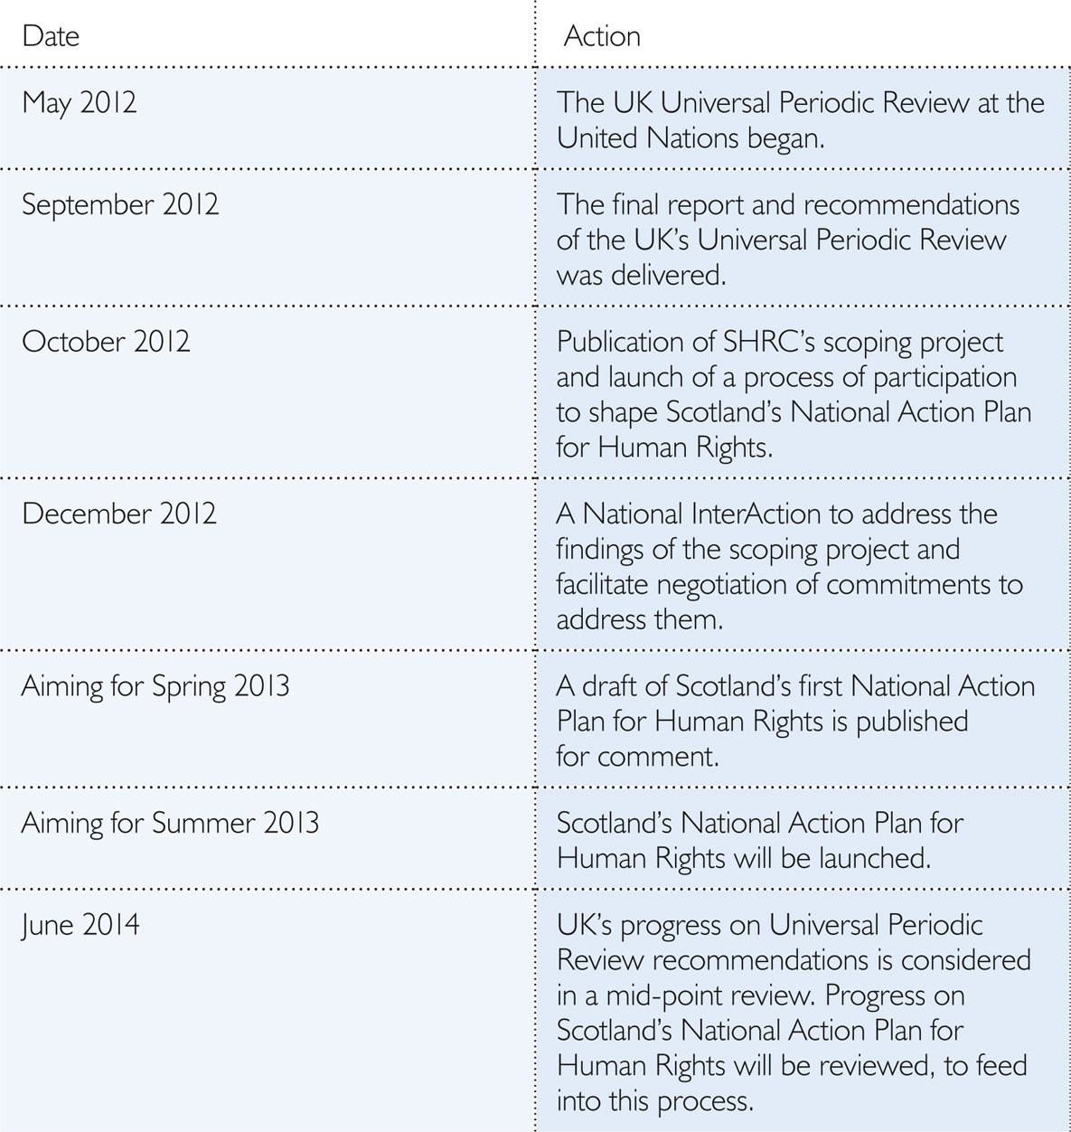

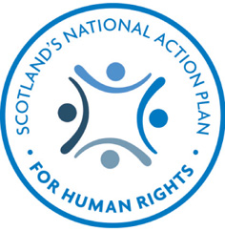

National Action Plans for Human Rights have already been developed in around 30 countries across the world including New Zealand, Australia, Sweden, Spain, Finland and South Africa. Plans from a selection of countries can be viewed at the website of the United Nations High Commissioner for Human Rights.

Over the past two decades the UN has encouraged and supported countries to develop National Action Plans, stressing their importance in identifying gaps in human rights protection, clarifying the responsibilities of States, and establishing monitoring systems so that progress made in promoting and fulfilling human rights protection can be measured over time.

Scotland has the benefit of learning from the experience of others in developing a National Action Plan, and the Scottish Human Rights Commission is grateful for their support in
this process.

Navi Pillay, United Nations High Commissioner for Human Rights:
“It is very important that countries develop and implement national action plans with the participation of civil society, public bodies, United Nations experts, academics, parliaments and individuals. National action plans can bring clarity to States in identifying the steps they must take to improve the promotion and protection of human rights, especially for the most vulnerable people. I am pleased to welcome the initiative taken by the Scottish Human Rights Commission to carry out this broad consultation.”

Nils Muižnieks, Commissioner for Human Rights, Council of Europe:
“I welcome the development of a National Action Plan for Human Rights in Scotland. To develop an action plan openly presenting problems and a process of developing practical solutions is a signal of commitment to human rights. Scotland is joining an increasing number of countries across Europe that have developed and implemented National Action Plans to support the full realization of human rights in practice. I look forward to engaging with this process.”

Mattias Falk, International Coordinator of the Swedish Equality Ombudsman:
“Our experience of National Action Plans in Sweden, where the Government is currently drafting its third action plan, has been both positive and productive. The purpose of the National Action plan was to carry out a coherent review of the human rights situation in Sweden and, on the basis of the review, to propose measures for more systematic work with human rights at the national level. We warmly welcome the development of a National Action Plan for Scotland and strongly recommend that everyone works together with the Scottish Human Rights Commission in this important process for securing human rights in Scotland.”

Sirpa Rautio, Director of the Human Rights Centre of Finland:
“Finland has recently adopted a National Action Plan on Fundamental and Human Rights, which translates into concrete terms the duty to guarantee the observance of fundamental rights and human rights imposed on public authorities by the Constitution. The action plan will enhance the implementation of fundamental and human rights in Finland, and was drafted by a working group which brought together representatives of all Ministries, the Office of the Chancellor of Justice and the Office of the Parliamentary Ombudsman. The drafting process also involved open dialogue and engagement with representatives of NGOs and other human rights actors

”We are very pleased to learn of the development of a National Action Plan in Scotland and offer our full support. National Action Plans are an important tool in the realisation of human rights, they can hold states to account, ensure cordination in implementing and reporting on international obligations and promote a culture of human rights.”

The Hon Catherine Branson QC, President, Australian Human
Rights Commission:
“In Australia, the process of establishing a human rights action plan has been led by the national government. To date it has been a positive process - with a focused dialogue with the community about the most important human rights issues that we face. The plan will be in place from July 2012. Our aim has been to achieve a better connection between the domestic actions taken to protect human rights and our international obligations. There is a particularly clear connection between the outcomes of the Universal Periodic Review of Australia and the proposed priority actions by government over the next 3 years. As the national human rights institution of Australia, we intend to use the Action Plan to hold the government to account in meeting its human rights obligations, and in measuring our progress in improving human rights over time.”

“We encourage everyone in Scotland to engage with the Scottish Human Rights Commission in developing your national action plan on human rights. Our Commission’s motto is ‘human rights: everyone, everywhere, everyday’. Your engagement in this process contributes to making these words true. Everyone has a role in shaping the human rights priorities for their country: I urge you to make your voice heard. National action plans can help to hold governments to account, and bring about real change in institutions and organizations, as well as giving clarity on human rights obligations for the future.”

A list with links to all National Action Plans can be viewed at the website of the United Nations Office of the High Commissioner for Human Rights.

The United Nations office of the High Commissioner for Human Rights has also produced a Handbook for national human rights institutions which gives detailed information and background to forming National Action Plans.



